SIMATS ENGINEERING
Assignment
COURSE NAME: OBJECT ORIENTED ANALYSIS AND DESIGN
COURSE CODE: CSA11

COURSE OUTCOME COVERED
CO1: Analyse the fundamentals of Object-Oriented Systems Development, including object basics, Object-Oriented Systems Development Life Cycle, Object-Oriented Methodologies, Model-Driven Development (MDD), and Agile practices.
CO2: Apply UML techniques including Use Case, Class, Interaction, State Transition, Activity, Package, Component, and Deployment Diagrams to model a software system.
CO3: Analyse objects, classes, attributes, methods, and relationships through Use Case Modelling, Object Analysis, Classification, and identification of object relationships.

Assignment Weightage: 100%

QUESTIONS: 1 Total Marks:100
Annexure A
Assignment

Code of Conduct:

I ____________________ (Name / Reg No) certify that this submission is my original work and that I have adhered to the guidelines specified for this assessment.
I understand that any violation of academic integrity rules will result in disciplinary action.

Signature of the student:

Course Code & Name | CSA11 – Object Oriented Analysis and Design
Assignment Title | Object-Oriented Analysis and UML-Based Design of an AI-Enabled Smart Healthcare Appointment and Patient Support System (AI-SHAPS)
Course Outcome(s) – CO | CO1: Analyse the fundamentals of Object-Oriented Systems Development, including object basics, Object-Oriented Systems Development Life Cycle, Object-Oriented Methodologies, Model-Driven Development (MDD), and Agile practices.  CO2: Apply UML techniques including Use Case, Class, Interaction, State Transition, Activity, Package, Component, and Deployment Diagrams to model a software system.  CO3: Analyse objects, classes, attributes, methods, and relationships through Use Case Modelling, Object Analysis, Classification, and identification of object relationships.
Bloom’s Taxonomy Level | BL3 – Apply, BL4 – Analyse, BL5 – Evaluate, BL6 – Create
SDG Mapping (SDG 1–17) | SDG 4 – Quality Education  SDG 9 – Industry, Innovation and Infrastructure  SDG 11 – Sustainable Cities and Communities

Problem Statement
Analyse and develop an Object-Oriented Analysis and Design model for an AI-Enabled Smart Healthcare Appointment and Patient Support System (AI-SHAPS). The system shall integrate patients, doctors, reception staff, administrators, laboratory personnel, and pharmacy staff through a centralized intelligent platform. Patients shall register, manage profiles, search doctors, book/reschedule/cancel appointments, receive reminders, view prescriptions and laboratory reports, and submit service requests. Doctors shall manage availability, appointments, clinical notes, prescriptions, and follow-up requests. The system shall provide intelligent doctor/slot recommendations based on specialty, availability, patient preferences, and historical appointment patterns. Laboratory and pharmacy modules shall update report and prescription status. Working from this scenario, students shall identify actors, objects, classes, attributes, methods, and relationships and develop Use Case, Class, Sequence, Activity, State Transition, Package, Component, and Deployment Diagrams. Students shall evaluate object responsibilities and apply appropriate design principles and patterns to achieve modularity, maintainability, reusability, security, and scalability.

Constraints
The system shall clearly define the system boundary, actors, objects, classes, attributes, operations, and relationships. UML diagrams shall be consistent with one another, and the operations identified in the Class Diagram shall support the interactions represented in the Sequence and Activity Diagrams.
The design shall demonstrate appropriate use of encapsulation, abstraction, inheritance, polymorphism, cohesion, coupling, and responsibility assignment. Suitable design patterns shall be selected and justified based on the identified design problems.
The final model shall document assumptions and constraints and ensure that all UML models are complete, consistent, unambiguous, traceable, and feasible.

Tools Can Be Used
- StarUML
- Visual Paradigm
- Draw.io
- PlantUML
- Papyrus Tools
- ArgoUML
- Enterprise Architect
- Lucidchart

Assessment Rubrics
Criteria (CO Mapping) | Max Marks | Excellent | Good | Satisfactory | Needs Improvement
Problem Understanding, Object Identification & Requirements Analysis (CO1) | 10 | Clearly analyses the problem domain and accurately identifies all major actors, objects, system responsibilities, and requirements from the given scenario. | Identifies most actors, objects, and requirements with minor gaps or inaccuracies. | Identifies basic actors and objects but analysis is incomplete or contains some inconsistencies. | Poor understanding of the problem; major actors, objects, and requirements are missing or incorrectly identified.
Use Case Modelling & Actor Identification (CO2) | 10 | Correctly identifies all relevant actors and use cases; Use Case Diagram clearly represents system boundary, relationships, and interactions. | Most actors and use cases are correctly identified with minor modelling errors. | Basic actors and use cases are identified, but relationships or system boundary need improvement. | Actors and use cases are poorly identified; diagram is incomplete or inconsistent.
Class Identification, Attributes, Methods & Relationships (CO2/CO3) | 15 | Classes, attributes, methods, associations, aggregation/composition, inheritance, and dependencies are accurately identified and logically justified. | Class structure is mostly correct with minor errors in attributes, methods, or relationships. | Basic classes and relationships are identified but lack detail or contain several modelling issues. | Classes, attributes, methods, or relationships are missing, inappropriate, or poorly structured.
UML Behavioural & Interaction Modelling (CO2) | 15 | Sequence, Activity, and State Transition Diagrams accurately represent system behaviour and are fully consistent with the identified use cases and classes. | Behavioural diagrams are mostly correct with minor inconsistencies. | Basic behavioural diagrams are provided but some interactions, activities, or states are incomplete. | Behavioural diagrams are missing, unclear, or inconsistent with the proposed system.
UML Architectural Modelling & Design Evaluation (CO3) | 15 | Package, Component, and Deployment Diagrams clearly represent modular structure, system components, dependencies, and deployment environment with strong justification. | Architectural diagrams are mostly correct with minor omissions or modelling errors. | Basic architectural representation is provided but lacks clarity or sufficient justification. | Architectural diagrams are incomplete, inappropriate, or inconsistent with the system design.
Object Responsibilities, Design Principles, Axioms & Patterns (CO3) | 15 | Responsibilities are appropriately assigned; design axioms, cohesion, coupling, encapsulation, abstraction, and suitable design patterns are clearly justified and effectively applied. | Design principles and patterns are appropriately applied with minor limitations in justification. | Some design principles are identified, but application or justification is limited. | Design principles, axioms, responsibilities, or patterns are absent or incorrectly applied.
Consistency, Traceability & Overall Design Quality (CO3) | 10 | All UML models are mutually consistent, requirements are traceable to use cases/classes, and the overall design is complete, feasible, scalable, and maintainable. | Design is largely consistent and traceable with minor gaps. | Some consistency and traceability are demonstrated, but important links are missing. | Major inconsistencies exist between requirements, use cases, classes, and UML diagrams.
Reflection, SDG Relevance & Learning Outcomes | 10 | Provides insightful reflection on design decisions, challenges, OOAD concepts learned, and clearly establishes the relevance of the selected SDGs. | Provides good reflection with reasonable connection to design decisions and SDGs. | Reflection is present but generic with limited discussion of learning and SDG relevance. | Reflection is missing, superficial, or unrelated to the assignment and SDGs.
Total | 100

Deliverables
To receive full credit, each submission must include the following:
- Problem Analysis and Requirement Summary
- Actor Identification
- Use Case Descriptions
- Use Case Diagram
- Object and Class Identification
- Class Diagram
- Sequence/Interaction Diagram(s)
- Activity Diagram
- State Transition Diagram
- Package Diagram
- Component Diagram
- Deployment Diagram
- Object Responsibility Analysis
- Design Axioms/Principles and Design Pattern Justification
- Assumptions and Constraints
- Requirement-to-Use Case/Class Traceability
- Implementation/Prototype and Results
- Reflection on Design Decisions and Learning Outcomes
- GitHub Upload

1. Problem Analysis and Requirement Summary
1.1 System Name
AI-Enabled Smart Healthcare Appointment and Patient Support System (AI-SHAPS)
1.2 Problem Analysis
AI-SHAPS is a centralized intelligent healthcare platform designed to connect patients, doctors, reception staff, administrators, laboratory personnel, and pharmacy staff.
The system manages the complete appointment and patient-support process. Patients can register, maintain their profiles, search for doctors, book/reschedule/cancel appointments, receive reminders, view prescriptions and laboratory reports, and submit service requests.
Doctors can manage their availability, appointments, clinical notes, prescriptions, and follow-up requests.
The system also provides AI-based doctor and appointment-slot recommendations using:
- Doctor specialty
- Doctor availability
- Patient preferences
- Historical appointment patterns
Laboratory and pharmacy personnel can update the status of reports and prescriptions.
The assignment specifically requires the system to be modelled using Use Case, Class, Sequence, Activity, State Transition, Package, Component, and Deployment diagrams.
1.3 Functional Requirements
Patient requirements
The patient shall be able to:
- Register an account.
- Login to the system.
- Manage their profile.
- Search for doctors.
- View doctor information.
- Receive intelligent doctor recommendations.
- Receive appointment-slot recommendations.
- Book an appointment.
- Reschedule an appointment.
- Cancel an appointment.
- Receive appointment reminders.
- View prescriptions.
- View laboratory reports.
- Submit service requests.
- View appointment history.
Doctor requirements
The doctor shall be able to:
- Login.
- Manage availability.
- View appointments.
- Accept/manage appointments.
- Add clinical notes.
- Create prescriptions.
- View patient information.
- Create follow-up requests.
Reception Staff requirements
The reception staff shall be able to:
- Register/manage patients.
- Manage appointments.
- Reschedule appointments.
- Cancel appointments.
- Assist patients with appointment-related requests.
Administrator requirements
The administrator shall be able to:
- Manage users.
- Manage doctors.
- Manage system configuration.
- Monitor system activities.
- Manage access and permissions.
Laboratory Personnel requirements
Laboratory personnel shall be able to:
- View laboratory requests.
- Update laboratory report status.
- Upload/update laboratory reports.
Pharmacy Staff requirements
Pharmacy staff shall be able to:
- View prescriptions.
- Process prescriptions.
- Update prescription status.
These requirements are derived directly from the responsibilities specified in the problem statement.

2. Actor Identification
The main actors are:
Actor | Responsibility
Patient | Registration, profile, doctor search, appointment management, reports, prescriptions, service requests
Doctor | Availability, appointments, clinical notes, prescriptions, follow-ups
Reception Staff | Patient and appointment assistance
Administrator | User/system administration
Laboratory Personnel | Laboratory reports and status
Pharmacy Staff | Prescription processing and status
Notification Service | Sends appointment reminders/notifications
AI Recommendation Engine | Provides doctor and slot recommendations
The six primary human actors are explicitly identified by the assignment's problem statement.

3. Use Case Identification
Patient Use Cases
- Register
- Login
- Manage Profile
- Search Doctor
- View Doctor Details
- Get Doctor Recommendation
- Get Slot Recommendation
- Book Appointment
- Reschedule Appointment
- Cancel Appointment
- Receive Reminder
- View Prescription
- View Laboratory Report
- Submit Service Request
- View Appointment History
Doctor Use Cases
- Login
- Manage Availability
- View Appointments
- Manage Appointment
- View Patient Information
- Add Clinical Notes
- Create Prescription
- Create Follow-up Request
Reception Staff Use Cases
- Manage Patient
- Book Appointment
- Reschedule Appointment
- Cancel Appointment
- View Appointment
Administrator Use Cases
- Manage Users
- Manage Doctors
- Manage Roles and Permissions
- Monitor System
Laboratory Personnel Use Cases
- View Laboratory Request
- Upload Laboratory Report
- Update Report Status
Pharmacy Staff Use Cases
- View Prescription
- Process Prescription
- Update Prescription Status

4. Use Case Descriptions
UC01 – Register Patient
Actor: Patient
Precondition: Patient does not already have an account.
Main Flow:
- Patient selects Register.
- System displays registration form.
- Patient enters required details.
- System validates the details.
- System creates the patient account.
- System confirms successful registration.
Postcondition: Patient account is created.
UC02 – Search Doctor
Actor: Patient
Precondition: Patient is logged in.
Main Flow:
- Patient enters specialty or preference.
- System searches available doctors.
- System displays matching doctors.
- Patient selects a doctor.
- System displays doctor details and available slots.
Postcondition: Suitable doctors and available slots are displayed.

5. AI Doctor/Slot Recommendation
Actor: Patient
Supporting Component: AI Recommendation Engine
Main Flow
- Patient provides search requirements.
- System obtains doctor specialties.
- System checks doctor availability.
- System obtains patient preferences.
- System analyzes historical appointment patterns.
- AI engine calculates suitable recommendations.
- System displays recommended doctors and slots.
- Patient selects a suitable recommendation.
The recommendation factors must specifically include specialty, availability, patient preferences, and historical appointment patterns, as stated in your assignment.

6. Book Appointment
Actor: Patient
Main Flow
- Patient selects a doctor.
- System displays available slots.
- Patient selects a slot.
- System verifies slot availability.
- System creates the appointment.
- System updates the slot status.
- System sends confirmation.
- System schedules a reminder.
Postcondition: Appointment is successfully booked.

7. Object and Class Identification
The important classes are:
User
- userId
- name
- email
- phone
- password
- role
Patient
- patientId
- dateOfBirth
- gender
- preferences
- medicalHistory
Doctor
- doctorId
- specialization
- qualification
- availability
Appointment
- appointmentId
- date
- time
- status
- reason
AppointmentSlot
- slotId
- date
- startTime
- endTime
- status
ClinicalNote
- noteId
- noteDate
- description
Prescription
- prescriptionId
- date
- status
PrescriptionItem
- itemId
- medicineName
- dosage
- duration
LaboratoryReport
- reportId
- testName
- reportDate
- reportStatus
- reportFile
ServiceRequest
- requestId
- requestType
- description
- status
- createdDate
FollowUpRequest
- followUpId
- requestedDate
- reason
- status
Recommendation
- recommendationId
- recommendationType
- score
- generatedDate
Notification
- notificationId
- message
- notificationType
- sentTime
- status

8. Class Diagram
The following is the correct logical class structure for your AI-SHAPS system.
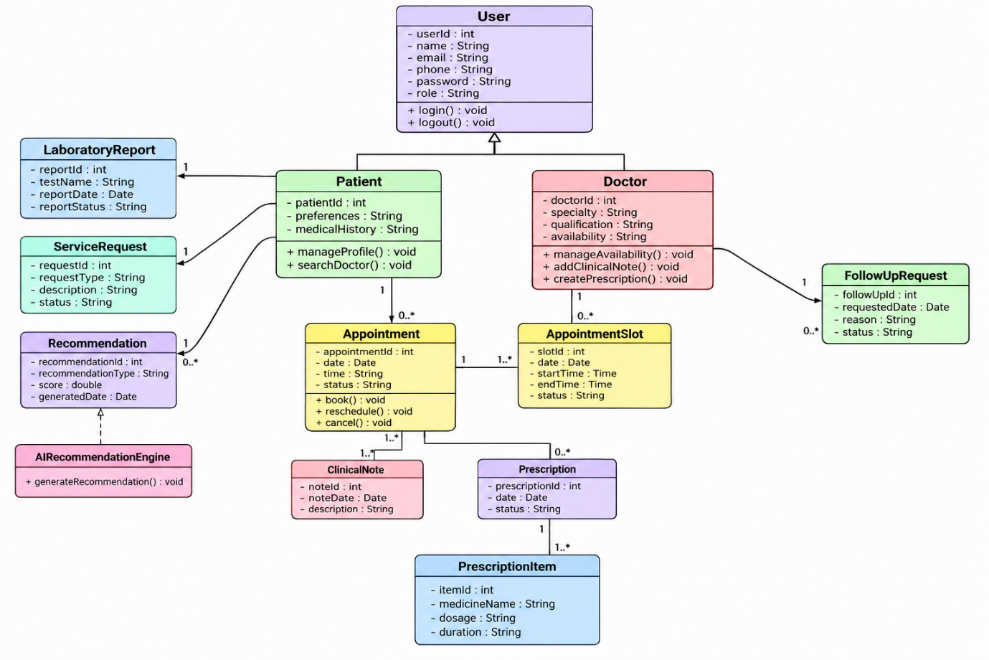

9. Important Relationships
Patient – Appointment
Association
One patient can have many appointments.
Patient 1 -------- 0..* Appointment
Doctor – Appointment
Doctor 1 -------- 0..* Appointment
Appointment – AppointmentSlot
An appointment uses one appointment slot.
Appointment 1 -------- 1 AppointmentSlot
Doctor – ClinicalNote
Doctor 1 -------- 0..* ClinicalNote
Patient – ClinicalNote
Patient 1 -------- 0..* ClinicalNote
Patient – Prescription
Patient 1 -------- 0..* Prescription
Prescription – PrescriptionItem
This can be composition because prescription items belong to a particular prescription.
Prescription 1 ◆-------- 1..* PrescriptionItem
Patient – LaboratoryReport
Patient 1 -------- 0..* LaboratoryReport
Patient – ServiceRequest
Patient 1 -------- 0..* ServiceRequest
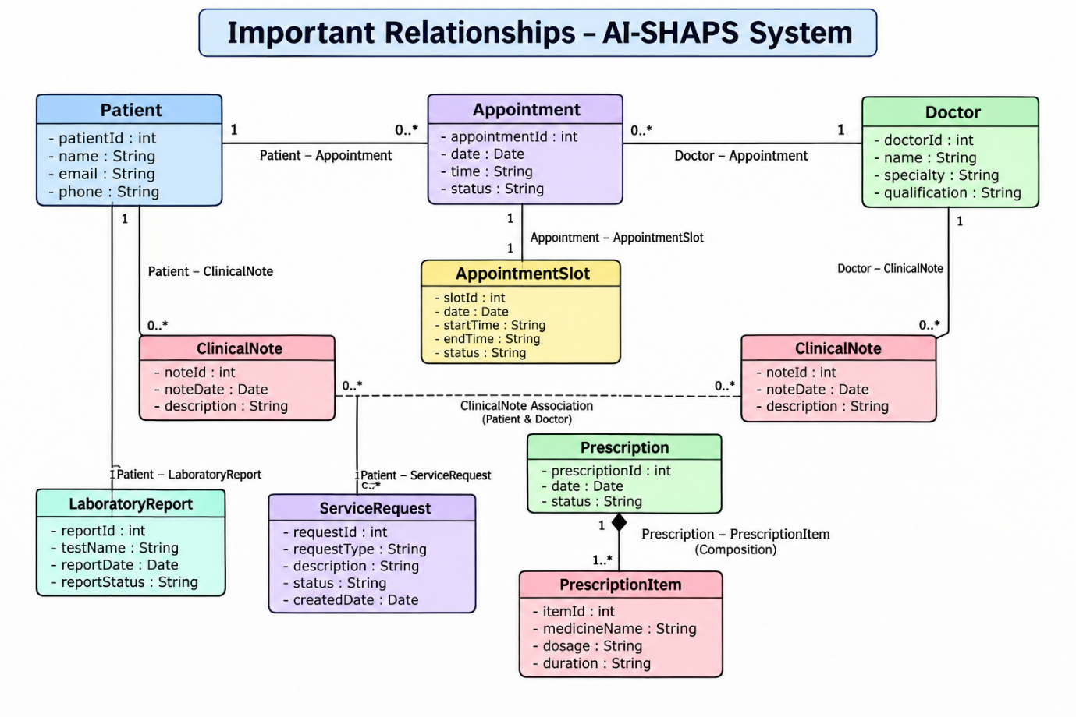
10. Inheritance
A suitable inheritance hierarchy is:
Administrator can also be modelled as a specialized user/staff role depending on the implementation.
Why inheritance?
Common attributes such as:
- userId
- name
- email
- phone
- password
can be defined in User.
Specialized classes inherit these common properties.
This demonstrates inheritance and reuse, while avoiding duplicate attributes.
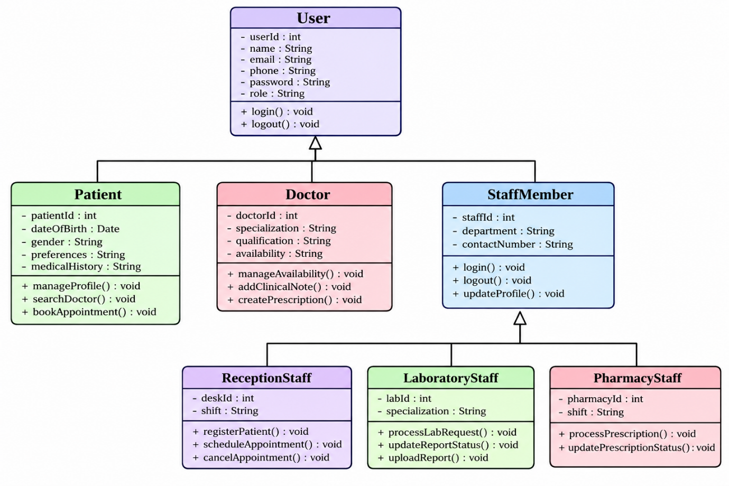
11. Sequence Diagram – Book Appointment
Scenario
Patient books an appointment using an AI-recommended slot.
Patient
|
| searchDoctor()
v
AI Recommendation Engine
|
| requestRecommendation()
v
Doctor Availability
|
| availableSlots
v
AI Recommendation Engine
|
| recommendedDoctorsAndSlots
v
Patient
|
| selectSlot()
v
Appointment
|
| verifyAvailability()
v
AppointmentSlot
|
| available
v
Appointment
|
| createAppointment()
v
Notification Service
|
| sendConfirmation()
v
Patient
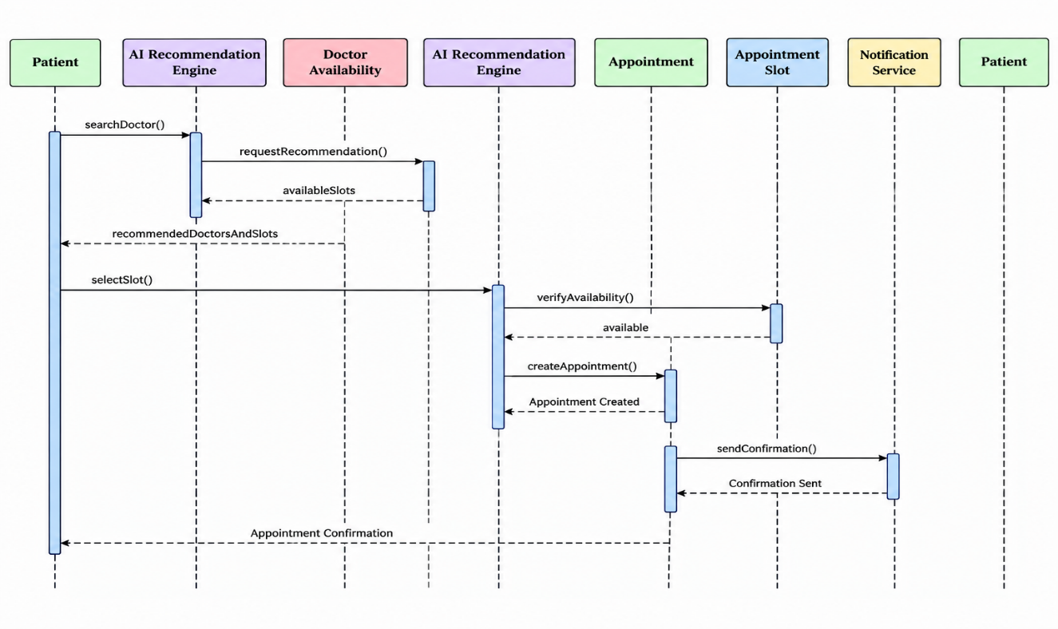
12. Activity Diagram – Appointment Booking
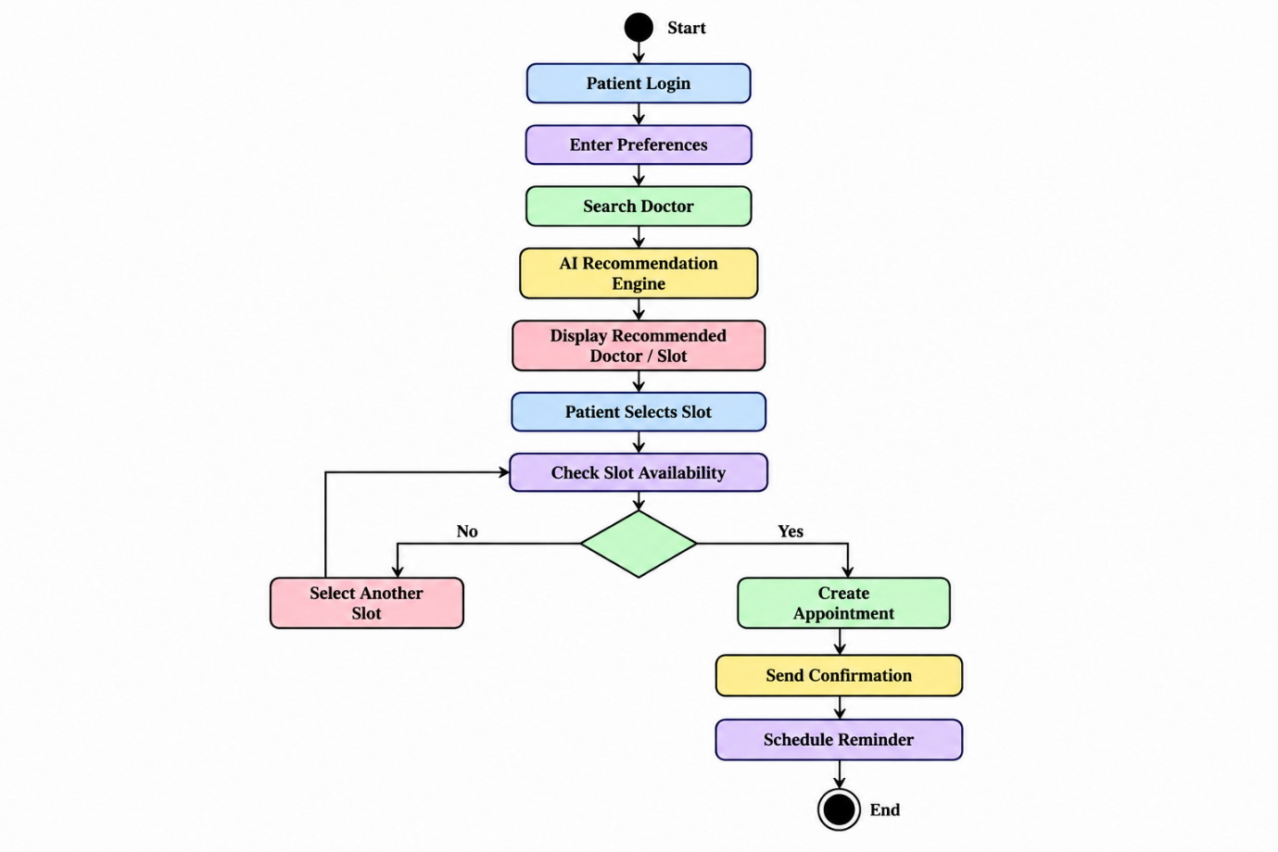

13. State Transition Diagram – Appointment
The assignment specifically requires a State Transition Diagram.
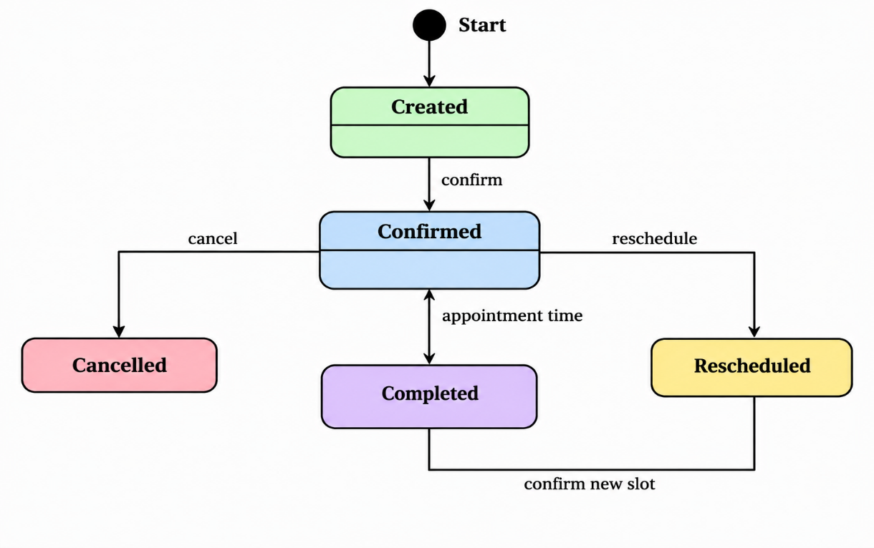
Appointment States
- Created
- Confirmed
- Rescheduled
- Cancelled
- Completed

14. Package Diagram
The system can be divided into the following packages:
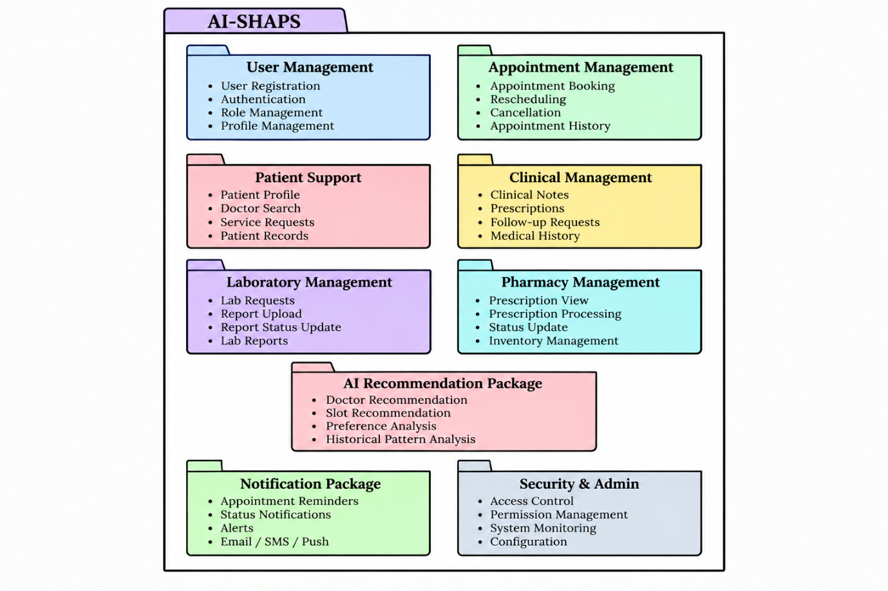

- Component Diagram
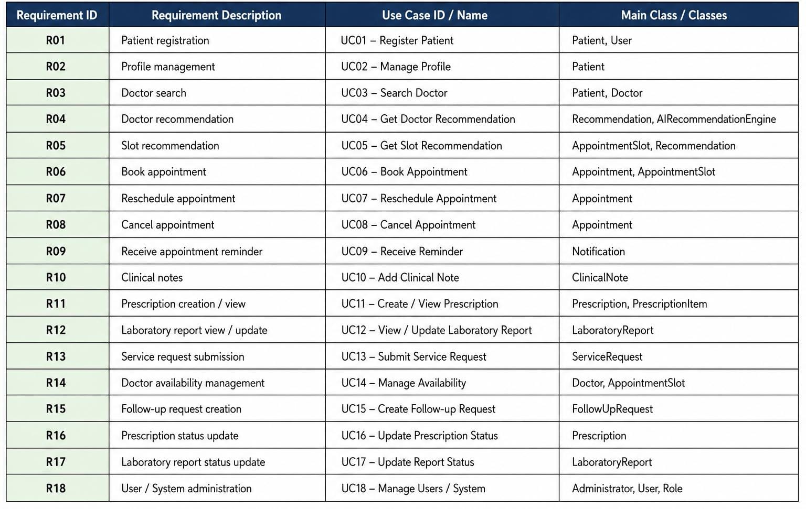

17. Object Responsibility Analysis
Object/Class | Main Responsibilities
Patient | Manage profile, search doctors, book/reschedule/cancel appointments, view records
Doctor | Manage availability, appointments, clinical notes and prescriptions
Appointment | Maintain appointment date, time and status
Appointment Slot | Maintain available time slots
Prescription | Manage prescription information and status
Laboratory Report | Store and manage laboratory report information
ServiceRequest | Manage patient service requests
Recommendation | Store recommendation results
AI Recommendation Engine | Generate doctor and slot recommendations
Notification | Send appointment confirmations and reminders
Administrator | Manage users, roles and system configuration

The assignment explicitly requires appropriate responsibility assignment and consideration of cohesion, coupling, encapsulation and abstraction.

18. OO Design Principles
18.1 Encapsulation
Patient information should be private within the Patient class.
Patient
----------------
-private medicalHistory
-private preferences

+getMedicalHistory()
+updatePreferences()
This prevents uncontrolled direct access to sensitive information.

18.2 Abstraction
The system can provide a common NotificationService interface without exposing the internal implementation.
NotificationService
|
+---- EmailNotification
|
+---- SMSNotification
|
+---- PushNotification
The user only needs to know that a notification will be sent.

18.3 Inheritance
User
|
+---- Patient
|
+---- Doctor
|
+---- StaffMember
Common user information can be reused.

18.4 Polymorphism
Notification services can demonstrate polymorphism.
NotificationService
|
+-----+------+------+
| | |
Email SMS Push
Each implementation can have:
sendNotification()
but the actual behavior differs.

19. Coupling and Cohesion
Low Coupling
Each module should have minimal dependency on other modules.
For example:
The Appointment module should not directly contain laboratory-processing logic.
Instead, it communicates with the Laboratory module through defined interfaces.

High Cohesion
Each class/module should have closely related responsibilities.
For example:
The Appointment class should manage appointment-related information and operations rather than user authentication.
The assignment specifically expects appropriate application of cohesion and coupling.

20. Design Patterns
20.1 Strategy Pattern – AI Recommendation
Different recommendation strategies can be used.
RecommendationStrategy
|
+----+----+
| |
Specialty Availability
Strategy Strategy
The system can select the appropriate recommendation strategy based on requirements.

20.2 Factory Pattern – Notification
A factory can create different notification types.
NotificationFactory
|
+---- EmailNotification
+---- SMSNotification
+---- PushNotification
This avoids creating notification objects directly throughout the application.

20.3 Observer Pattern – Appointment Reminder
When an appointment changes:
Appointment
|
| status changed
v
Notification System
|
+--+---+
| |
SMS Email
This is suitable for appointment reminders and status notifications.

21. Assumptions
The following assumptions can be documented:
- Every patient has a unique patient ID.
- Every doctor has a unique doctor ID.
- Users must authenticate before accessing protected functions.
- Doctors maintain their available appointment slots.
- A booked slot cannot simultaneously be booked by another patient.
- Patients can only access their authorized medical information.
- Laboratory personnel are responsible for updating laboratory report status.
- Pharmacy personnel are responsible for updating prescription status.
- AI recommendations are based on specialty, availability, patient preferences and historical appointment patterns.
- Notifications are generated after important appointment events.
- Administrators manage roles and permissions.
- The database securely stores patient, appointment and clinical information.

22. Constraints
The assignment requires the design to maintain consistency between UML models and ensure that class operations support interactions in the Sequence and Activity diagrams.
System constraints
- Patient data must be protected.
- Only authorized users can access sensitive records.
- Appointment slots cannot be double-booked.
- UML diagrams must remain mutually consistent.
- AI recommendations depend on available historical data.
- The system should support scalability.
- The system should maintain modularity.
- The system should be maintainable and reusable.
- The system should provide secure authentication and authorization.

23. Requirement-to-Use Case/Class Traceability
This is important for your 100-mark rubric because your assignment explicitly asks for requirement-to-use-case/class traceability.
Requirement | Use Case | Main Class
Patient registration | Register | Patient/User
Profile management | Manage Profile | Patient
Doctor search | Search Doctor | Patient/Doctor
Doctor recommendation | Get Recommendation | Recommendation/AI Engine
Slot recommendation | Get Slot Recommendation | AppointmentSlot/AI Engine
Book appointment | Book Appointment | Appointment
Reschedule | Reschedule Appointment | Appointment
Cancel | Cancel Appointment | Appointment
Reminder | Receive Reminder | Notification
Clinical notes | Add Clinical Note | ClinicalNote
Prescription | Create/View Prescription | Prescription
Laboratory report | View/Update Report | LaboratoryReport
Service request | Submit Service Request | ServiceRequest
Doctor availability | Manage Availability | Doctor/AppointmentSlot
Follow-up | Create Follow-up Request | FollowUpRequest
Prescription status | Update Prescription Status | Prescription
Report status | Update Report Status | LaboratoryReport

24. Reflection
Reflection on Design Decisions and Learning Outcomes
The AI-SHAPS system helped demonstrate how Object-Oriented Analysis and Design can be applied to a real-world healthcare problem. The system was divided into different classes and modules based on their responsibilities.
The use of inheritance allows common user properties to be reused by Patient, Doctor and Staff classes. Encapsulation helps protect patient and medical information. Polymorphism can be used for services such as notifications and payment-independent healthcare communication mechanisms.
UML diagrams provide different views of the system. The Use Case Diagram represents user interactions, the Class Diagram represents the static structure, Sequence and Activity Diagrams represent system behavior, while State, Package, Component and Deployment diagrams represent dynamic and architectural aspects.
One important design challenge is maintaining consistency between the different UML models. For example, operations shown in the Class Diagram must support interactions shown in the Sequence Diagram.
The assignment's stated goal is to achieve modularity, maintainability, reusability, security and scalability, which are therefore key considerations in the proposed design.

25. SDG Relevance
Your assignment specifies:
- SDG 4 – Quality Education
- SDG 9 – Industry, Innovation and Infrastructure
- SDG 11 – Sustainable Cities and Communities
SDG 4 – Quality Education
The project provides an opportunity to apply software engineering, UML, AI and object-oriented design concepts to a real-world problem.
SDG 9 – Industry, Innovation and Infrastructure
AI-SHAPS uses intelligent recommendation technology and centralized digital infrastructure to improve healthcare service management.
SDG 11 – Sustainable Cities and Communities
A centralized digital healthcare platform can help organize healthcare services efficiently and support accessible digital healthcare systems.
26. Implementation / Prototype
For the prototype, the system can be divided into:
AI-SHAPS
│
├── User Management
├── Patient Management
├── Doctor Management
├── Appointment Management
├── AI Recommendation
├── Clinical Management
├── Laboratory Management
├── Pharmacy Management
├── Notification Management
└── Administration
Example prototype flow
Patient Login
↓
Search Doctor
↓
Enter Preferences
↓
AI Recommendation
↓
Recommended Doctor + Slot
↓
Book Appointment
↓
Confirmation
↓
Reminder
↓
Doctor Consultation
↓
Prescription / Lab Report
↓
Patient Views Records

27. Results
The proposed AI-SHAPS OOAD model provides:
- Clear identification of actors
- Clearly defined system requirements
- Object and class identification
- Appropriate class relationships
- Use Case modelling
- Behavioural modelling
- State modelling
- Architectural modelling
- Responsibility assignment
- Application of OO principles
- Appropriate design patterns
- Requirement traceability
- Modular system structure
These directly correspond to the deliverables specified in your uploaded assignment.

